Women’s Results and Standings
Rider | R1 | R2 | R3 | R4 | Total
Virginia Riches | 18 |  | 20 | 8 | 46
Kayla McSporan | 20 |  |  | 16 | 36
Vicki-Lynne Birks | 20 |  |  | 9 | 29
Laura Tomlinson |  |  |  | 20 | 20
Bronwyn Dolman | 18 |  |  |  | 18
Anna Kubilius |  |  |  | 18 | 18
Jane Johnson | 16 |  |  |  | 16
Jenny MacPherson |  |  |  | 14 | 14
Katey Elding |  |  |  | 12 | 12
Rachel Goud |  |  |  | 11 | 11
Jodie Batchelor |  |  |  | 10 | 10

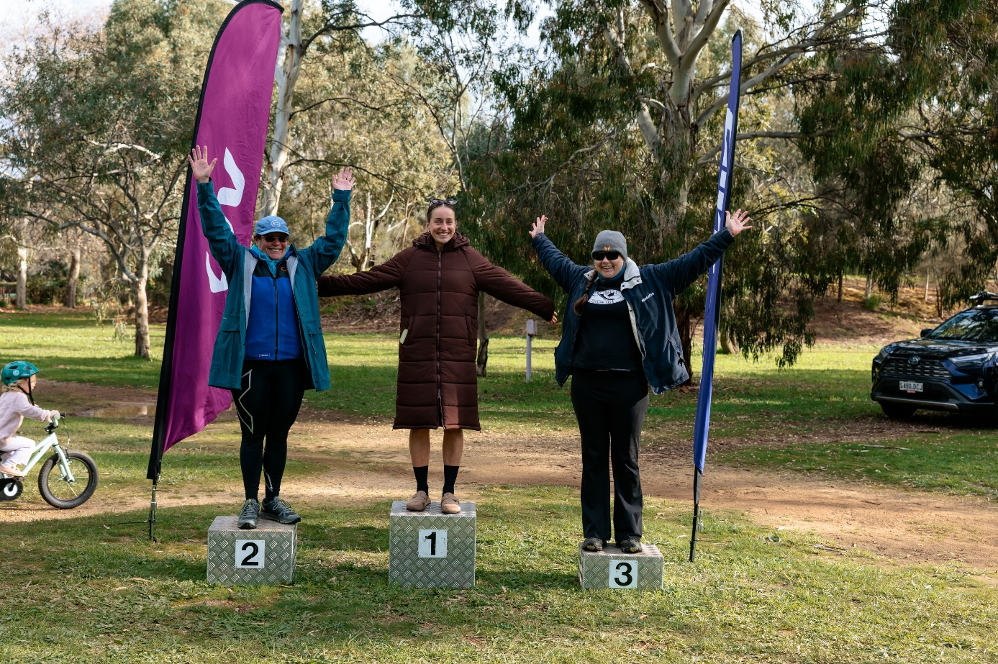

Men’s Results and Standings
Rider | R1 | R2 | R3 | R4 | Total
Darren Searle | 20 | 18 | 20 |  | 58
David Slater | 20 | 14 | 16 |  | 50
Carl Purczel | 16 |  | 11 | 5 | 32
Evan Hawkes |  | 20 |  |  | 20
Tom Chapman |  |  |  | 20 | 20
Barnaby Grant |  |  | 18 |  | 18
Cameron Mack | 18 |  |  |  | 18
Chris Cochinos | 18 |  |  |  | 18
Zachary Bryant |  |  |  | 18 | 18
Aidan Lampe |  |  |  | 16 | 16
George Vlahos |  | 16 |  |  | 16
Harry Williams |  |  |  | 14 | 14
Nathan Thomas |  |  | 14 |  | 14
Andrew Turnock |  |  | 12 |  | 12
Craig Eales |  | 12 |  |  | 12
Matthew Allen |  |  |  | 12 | 12
Bernard Harrington |  | 11 |  |  | 11
Tristan Glover |  |  |  | 11 | 11
Troy Bryant |  |  |  | 10 | 10
Phil Dixon |  |  |  | 9 | 9
Lewis Hewton |  |  |  | 8 | 8
Daniel Johns |  |  |  | 7 | 7
Tim Dougherty |  |  |  | 6 | 6
Aaron Austin-Glen |  |  |  | 5 | 5
Adam Hughes |  |  |  | 5 | 5
Adrian Rickards |  |  |  | 5 | 5
Daniel Drake |  |  |  | 5 | 5
Daniel Searson |  |  |  | 5 | 5
Dean Bottrill |  |  |  | 5 | 5
Geoff Cox |  |  |  | 5 | 5
George Evans |  |  |  | 5 | 5
Harry Duldig |  |  |  | 5 | 5
Jason Cattonar |  |  |  | 5 | 5
Joshua Kade |  |  |  | 5 | 5
Mark Arnold |  |  |  | 5 | 5
Mark Rupert |  |  |  | 5 | 5
Neil Petherbridge |  |  |  | 5 | 5
Richard Bates |  |  |  | 5 | 5
Stephen Nelson |  |  |  | 5 | 5

