
Port Adelaide Cycling Club Inc
Annual General Meeting 2026
Wednesday 20 May 2025, 6:30pm
The Golden Wattle, Adelaide

DRAFT Minutes of the 2026 Annual General Meeting (subject to ratification at the 2027 AGM)

 | Item | Responsible
 | Welcome and Apologies  Attendees:  - Barnaby Grant  - Benny Janssen  - Troy Bryant  - Madelene McNeil  - Michael Bails  - Lee-Anne Fleming  - Alfie Trimming  - Adam Hughes  - Jo Dettloff  - Felicity Gartelmann  - Aaron Brown  - Carl Purczel  - Virginia Riches  - Rachel Goud  - Gemma Kernich  - Tim Grisbrook  Proxies:  A quorum being achieved, the meeting was declared open. | President
  Name | Proxy to:
  Sean McKay | Gemma Kernich
  Mark Gregory | Gemma Kernich
  Paula Hollamby | Gemma Kernich
  Jodie Batchelor | Gemma Kernich
  Aaron Tetley | Barnaby Grant
  Robyn Cameron | Barnaby Grant
  Zach Bryant | Troy Bryant
  Nadia Henricks | Virginia Riches
  David Miller | Gemma Kernich
  Daniel Searson | Barnaby Grant
  Peter Davis | Barnaby Grant
  Susan Mitchell | Barnaby Grant
 | Minutes of 2025 AGM  That the minutes of the 2025 AGM be ratified.  Moved: Barnaby Grant  Seconded: Timothy Tuppence  All approved. | President
 | President’s Report  2026 has been an interesting year for cycling, both at the club level, and at the national level. We’ve seen some clubs raise concerns about the direction that AusCycling and the sport of cycling more generally are taking, and have seen what I felt to be a disappointing response from AusCycling to these clubs. I won’t go into the politics of this issue here, but I’m more than happy to discuss these issues over a coffee.  Having said that, the issues have been aired, and it feels that AusCycling has at least begun to demonstrate that they have been heard, so I hope that this is a turning point for the sport.  My focus for this year, and for the coming years, is on maintaining and increasing membership and engagement in PACC, and addressing the declining participation in cycling events across the State and the Country. The causes of this are many, but I believe that to turn things around, we must focus on three core areas.  The first is delivering on what we already do well.  - PACC is known for delivering high quality cyclocross events, time trials, and a range of entertaining events such as the Roller Frenzy during the TDU.  - These events are a draw to the sport and to the club, but they take a lot of work to deliver.  - To support this core area, we need to ensure we attract and retain volunteers.  The second is ensuring that PACC as a club is a vibrant and welcoming club.  - To this end, we’re focusing on organising some social rides and events, as well as regular track sessions at Hanson Reserve, which are accessible to nearly everyone.  The third is actively attracting young riders and their families.  - PACC has a low rate of junior membership, and without changing this, we’re going to go the same way as some other clubs who have effectively ceased operating.  - This year we published a Role Statement for a Junior Development Officer. We haven’t had any takers for the role yet, but this is a high priority.  The biggest initiative to support the third core area is a junior bike skills program called Bike Club, which we’re running on Tuesday nights at Hanson Reserve. This program is teaching kids from 5-12 years old, and was initially developed by Lee-Anne Fleming who ran the program in Term 1 to seven energetic kids. I and Stephen Nelson have taken over delivery of the program, and we now have 18 kids enrolled, and we still have nearly 10 kids on a waiting list for next term. We’re hoping that the kids involved in the program will participate in our CX events, and that their parents will also get involved as volunteers in the future.  If you’d like more information, please reach out to me.  Maeve Plouffe and I are also exploring a summer school holiday track camp at Hanson Reserve, so watch this space.  Women and Girls  I’m also delighted to announce that we have a Women and Girls Sub-committee, aimed at informing the board on any issues surrounding participation of women in PACC’s events, as well as ideas for attraction and retention of women and girls in the club. I’d like to acknowledge Susan Mitchell, Alfie Trimming, Virginia Riches and Kayla McSporran, who are the members of that subcommittee.  What’s coming up?  PACC’s Friday Night Social Rides are starting on the first Friday of every month, starting in June. Please join us at Plant 4 Bowden for a cruisy ride towards Port Adelaide, returning to Plant 4 for a drink and dinner. We’d love to see more PACCers coming out in club kit, and we promise a social paced ride!  Our regular Motopacing sessions continue on Thursday nights, with a massive thanks to Troy who facilitates these sessions.  Bike Club on Tuesday night is a hoot, and you’re welcome to come out and help out, run the BBQ, or just hang around and chat. We’d love if you could share the word with any friends who have kids between 5-12 who might be interested.  We’d also love people to run additional sessions. We’d love to see more training happening at Hanson, but our existing coaches and volunteers are at capacity.  The CX season is underway, and Troy has set up an exciting season between the tape. All events are now on EntryBoss, and there will be a season pass for the series. Giant Adelaide is sponsoring the series, and any rider who takes part in every round and the State CX Titles will be in the running to win a bike!  Finally, I’d like to acknowledge some of the Board Members who are not continuing.  Aaron Brown has been on the board for two years, and his expertise and knowledge around the track has been invaluable. We’re so excited to see his son Will racing on the world stage, and will track his progress eagerly.  Troy, whilst he’s remaining involved in the CX and Motopacing events, is also stepping down after two years. Troy’s efforts in running our CX events over the last few years have been legendary.  Tim Tuppence has been on the board since 2022, and his passion for CX has been incredible, as well as his ability to build and maintain relationships with sponsors and stakeholders which has been of massive benefit to the club.  Finally, someone who has been on the board of the club for more than 13 years, has served on the board of AusCycling after it was created 5 years ago, and has been a driving force for cycling in SA, Gemma Kernich is stepping down. Words fail me, and I can only hope you’ll still answer my phone calls.  Here’s to onwards! | President
 | Treasurer’s Report inc. Audited Financial Documents  The Treasurer’s Report and Audited Financial Statements were presented.  Motion to approve the Treasurer’s Report and approve the Audited Financial Statements: all approved. | Treasurer
 | Appointment of Auditor  Motion: That Phil Lounder be appointed as PACC’s auditor for the 2026/27 Financial Year  - Approved.  Motion: That a gift be given in appreciation to the Auditor:  - Approved. | Treasurer
 | Junior Scholarships  The winner of the Junior Scholarship for 2026 was William Brown.  William has had an excellent 2026 season so far, winning National Titles in the U19 category in the Criterium, Scratch Race, Omnium, Madison, and the Team Pursuit, where he was a member of the first state team to go under 4 minutes.  He also brought home the Oceanic Championship in the Madison and the Team Pursuit, and podiumed in the Scratch Race, Elimination, Individual Pursuit and Omnium.  William then headed to Europe, where he came 2nd in his first race before a crash temporarily halted his season. However, he has been selected to represent Australia in the Junior Track World Championships.  PACC congratulates William on his successes, and is delighted to continue to support William on his journey.  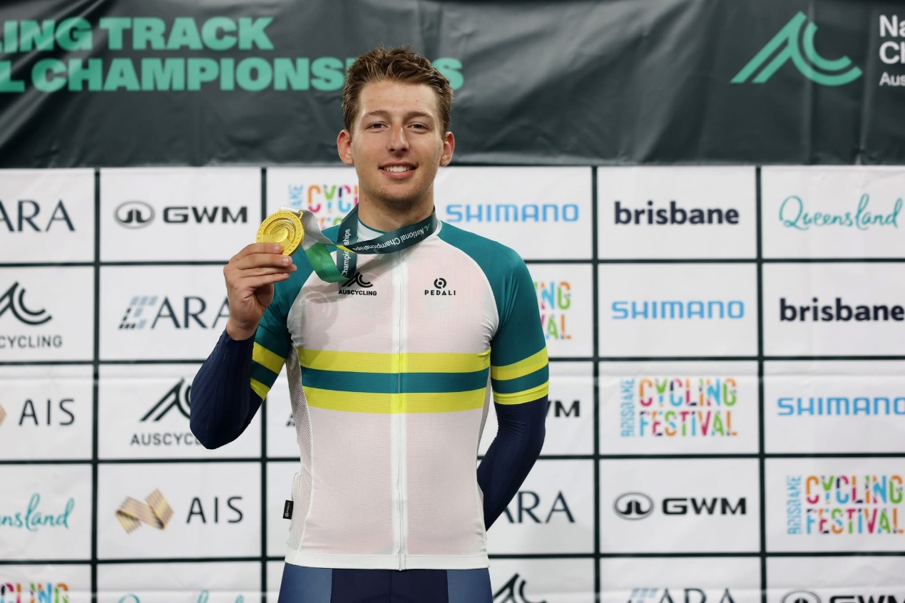 | President
 | Volunteer of the Year  The winner of the Volunteer of the Year award was Troy Bryant.  The PACC Board received three separate nominations for Troy as Volunteer of the year, and he was also recognised in the City of Port Adelaide Enfield Volunteer Appreciation Night.  Troy has been tireless in running PACC’s cyclocross program, and the phenomenal amount of work that he has done is unbelievable. From selecting and securing venues, planning competitions, arranging commissaires, food, coffee, sponsors, redesigning the points system, designing the course, and then delivering the event on race day, this massive undertaking has rested almost entirely on his shoulders this year.  He’s also the main reason that PACC’s motopacing sessions continue throughout the year.  It’s safe to say that without Troy, PACC would have a much smaller racing and training presence on the SA cycling calendar, and we are delighted to recognise in some small way his massive contributions to the club.  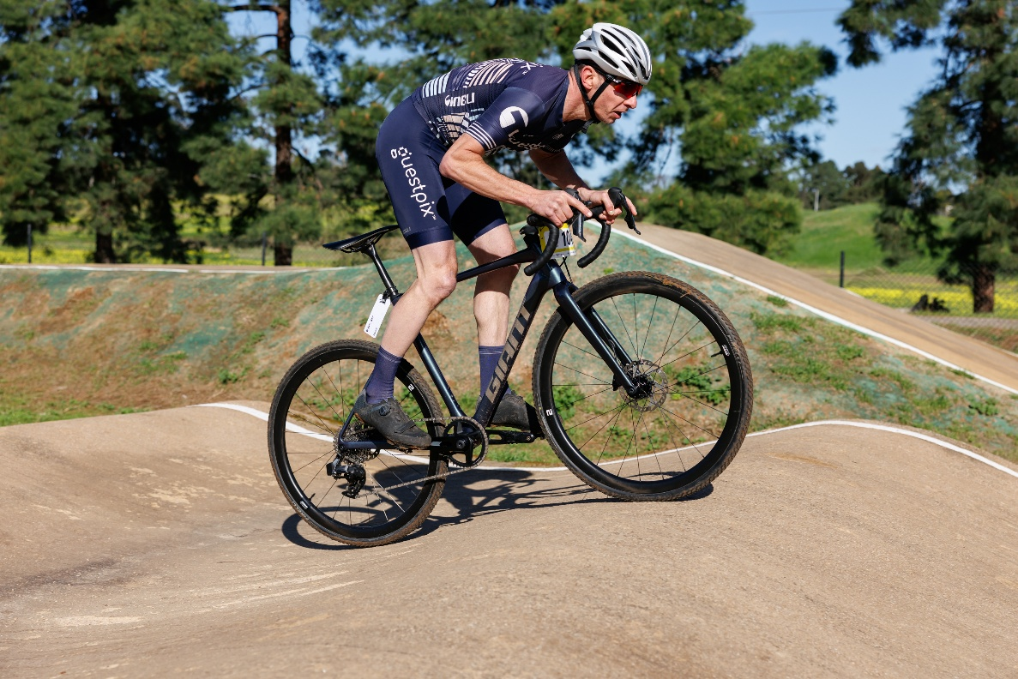 | President
 | Appointment of Life Member  Nomination:  Chris (or Spencey & King of Bling as he is widely known) is a long term PACC member. He is passionate about our Club and remains a race member, despite not racing competitively for some time.  Everyone who knows him knows he is a fun-loving larrikin with a cheeky sense of humour. But those who really know him, know that he wears his heart on his sleeve and is a kind and compassionate man who is generous with his time. He loves nothing more than imparting his knowledge to others - whether it be on how to repair a broken part or tinkering with bikes and bike bits or cars and car bits.  Track was his main passion having come from a competitive speed skating environment. His track bike is an amazing labour of love - with much bling added by way of custom gold parts, including handlebars, chainrings, and spokes, his fixie also has a somewhat dubious rear light (iykyk). He was a permanent fixture at Edwardstown Oval on a Friday night over summer. His signature black and white checked vans have been missed in recent years.  It’s always a pleasure to watch him racing shoulder to shoulder with experienced riders - pushing his friends and trusted rivals to their limits. He is also a coach and mentor to novices - teaching them the skills and tactics of the sport. Back when Cyclo Sportif’s were a regular feature on the calendar, he would proudly represent PACC encouraging riders of all ages and abilities to do their best. He loves all bikes and embraced cyclo cross from the early days when PACC started hosting events. He would attend races - set up and pack up and encourage riders with a cowbell and a heckle. He loved encouraging the kids and helping them over the barriers or up a hill.  After a serious injury in 2014, in March 2015 he was back on the bike – riding on a trainer with the handlebars turned upside down so he could reach the handlebars, neck brace still firmly in place. You can’t hold a good man down.  Spencey’s Palmares list is long. He has won multiple state and national championships across several disciplines pre and post accident. He has taken the top step of the podium at the Australian Masters Games on more than one occasion. Secretly, I think his greatest achievement was winning PACC’s Roller Frenzy in front of a packed crowd at the Kings Head Hotel in October 2015.  He and his wonderful wife Marion moved to Caboolture in 2018. His friends miss him dearly - and the velodrome sidelines are not the same without him. But despite the distance, he remains a dedicated and loyal PACCer.  Even from interstate Christopher has continued to race for PACC in the National E-Sports competition.  As an advocate for cycling and for PACC, I know that if the Board accepts this nomination and awards Spencey Life Membership, we will see his smile from Queensland.  Motion: That Christopher Spence be appointed as a Life Member of Port Adelaide Cycling Club. All approved.  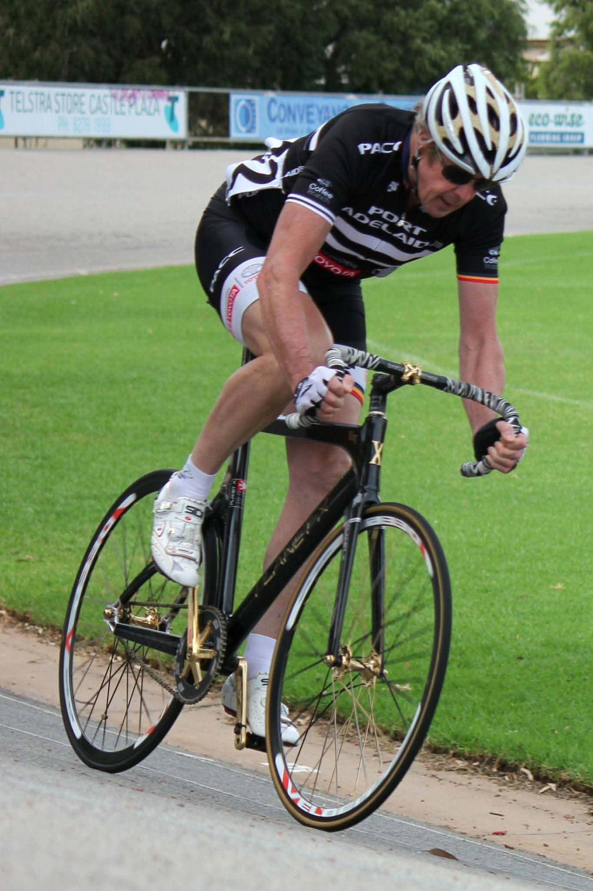 | Gemma Kernich
 | Questions
 | Appointment of Committee Members for 2026-27  The following 3 members were nominated for 3 vacant positions:  - Felicity Gartelmann  - Rohan Wight  - Madelene McNeil  All elected unopposed.  Continuing Board Members (terms expire at 2027 AGM)  - Barnaby Grant  - Adam Hughes  - Jo Dettloff | President

Date of Next Board Meeting: Monday 15 June 2026

